Augustus Mendy

Southern New Hampshire University

CS-360-10441-M01

Professor Brian Holbert

May 25, 2025

**7-2 Project Three Inventory Control App**

The programs' main features, including user registration, item tracking (including adding, removing, and increasing items), text notifications, and a grid layout for simple manipulation, are described. Furthermore, I would mention that the program was developed to monitor inventory that is kept in a database and to notify users when stock levels are low. The symbol is a crucial tool for drawing in potential users in addition to the application's description. INV to demonstrate that this software is for inventory tracking, an up-and-down arrow to show that it is for editing stock, and a fork truck, which is frequently used to carry large items around.

Designed to function smoothly on Android 11 and later devices, this application Released in 2020, this version is comparatively new. The application will have the ability to notify users of potential changes in the future and request their consent to utilize the camera to scan barcodes. While I don't intend to make money off of the app, it would be simple to do so if necessary by selling group licenses to companies or making them available for free for individual usage on the app store with banner ads included.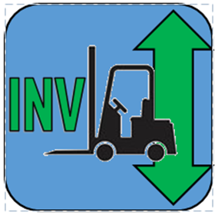

Reference:

Android. (2022, 04 17). Android. Retrieved from Android 11: <https://www.android.com/android-11/>.

Core App Quality. (2021, 03 17). Retrieved from developer.android.com: <https://developer.android.com/docs/quality-guidelines/core-app-quality>.